Final System Interfaces
And Transition

Mothership
Version 1.0
(Context Module)

The Brain Trust
ザ ブレイン トラスト
Akira Tsukamoto (Team Leader)  塚本 明 | at541@columbia.edu
Steven Osman (Integration Manager)  スティ－ブン オスマン | sto8@columbia.edu
Catherine (Weilun) Chang (Chief Tester)  キャサリン チャン | wc363@columbia.edu
Aner Fust (Lead Coder)  アネー ファスト | af590@columbia.edu

TA: | Shen Li
Integration TA: | James Lee

Table of Contents
1. Introduction 3
1.1. Changes since ISI 3
1.1.1. Component Directories 3
1.1.2. Calling Convention 3
1.1.3. Context Data Query Changes 3
1.2. Invoking the Login Interface 3
2. Export API and Schemas 4
2.1. Interface Usage 5
2.2. Exported Interfaces 6
2.2.1. Login Interface (MSL_*) 6
2.2.2. Context Data Query Interface (MSCQ_*) 7
2.2.3. Audit Log Insertion Interface (MSALI_*) 18
2.2.4. Audit Log Insertion Interface (MSALQ_*) 20
2.2.5. Context Data Maintenance Interface (MSCM_*) 21
2.2.6. Schema Definition Interface (MSSD_*) 23
3. Import API and Schemas 25
4. Installation and Use Instructions 26
4.1. Installation Instructions 26
4.2. User Manuals 27
4.2.1. User Manual: Interacting with the Login Screen 27
4.2.2. User Manual: Viewing Audit Log Events 28
4.2.3. User Manual: Maintaining Context Data 29
5. References and Glossary 47
6. Appendices 49
6.1. Sample Usage 49
6.1.1. Login Interface (MSL_*) 49
6.1.2. Context Data Query Interface (MSCQ_*) 50
6.1.3. Audit Log Insertion Interface (MSALI_*) 56
6.1.4. Audit Log Insertion Interface (MSALQ_*) 57
6.1.5. Context Data Maintenance Interface (MSCM_*) 58
6.1.6. Schema Definition Interface (MSSD_*) 60

Introduction

The Mothership system is the context module of CubCenter. The system provides numerous services to the other components essential to their functionality. The services offered to other modules include mechanisms to get login information, to query and update context information such as lists of students and classes, and insert and retrieve entries from CubCenter’s audit log. An API is also provided to maintain the schema of Mothership’s database.

The Mothership does not import any services from the other components.

Changes since ISI

The services offered by the Mothership system have not changed since the previous ISI. The majority of the changes apply to the naming conventions, and, in some instances, the format of the data returned by Mothership.

Component Directories
The Mothership system, when installed, will contain a number of subdirectories. The API calls into the system will be under one of the various directories, specifically, the entry point to each API will be:

Interface | Entry Point
Login | <MothershipPath>/Login/index.cfm
Context Data Query | <MothershipPath>/ContextDatabase/index.cfm
Context Data Maintenance | <MothershipPath>/ContextDatabase/index.cfm
Schema Definition | <MothershipPath>/ContextDatabase/index.cfm
Audit Log Insertion | <MothershipPath>/AuditLog/index.cfm
Audit Log Query | <MothershipPath>/AuditLogQuery/index.cfm

Calling Convention
The calling convention has changed slightly. Please refer to the example in section 5.2. For example, to invoke the context data query API, Now, rather than calling <CFModule template=”mothership/ContextDatabase/MSCQ_*”>, the appropriate call is <CFModule template=”mothership/ContextDatabase/index.cfm” fuseaction=”MSCQ_*”>

Context Data Query Changes
The format of the data returned by the Context Data Query Interface (the MSCQ_* functions) has been changed for ease of development. Please refer to the appropriate section for the new specifications.

Invoking the Login Interface
We recommend that you invoke the MSL_GetLogin interface function either at the top of your index.cfm or in your app_globals.cfm file. This will ensure that a user is properly logged into CubCenter before any futher execution of your module. The only time a different approach may be considered is if the entry point URL passed into MSL_GetLogin changes based on the user’s context (i.e. either by a specific entry point selected by the user).

Export API and Schemas

Login Interface
Description: This interface is used to access the user ID of the currently logged in user, or to request that that user be logged out. If no user is logged in, this interface will invoke a login screen. This interface also allows a caller to determine if a user is logged into the system.
Context Data Query Interface
Description: This interface provides read-only access to the context information stored in the system. The diagram in Appendix 1 illustrates the relationship between the various type of information. The interface allows you to generate lists of items, or retrieve details of a particular item.
Audit Log Insertion Interface
Description: This interface is used to add events to CubCenter’s event/audit log, which is managed by the Mothership System.
Audit Log Query Interface
Description: This interface is used to invoke the audit log query/display screen.
Context Data Maintenance Interface
Description: This interface is used to update the data stored in CubCenter’s context database.
Schema Definition Interface
Description: This interface is used to add entity types, relationship types, and to specify what types of relationships are allowed between specific entity types.

Interface Usage

Module | Interfaces Used
Homework | Login  Audit Log Insertion  Context Data Query
Virtual TA Room | Login  Audit Log Insertion  Context Data Query
Calendar | Login  Audit Log Insertion  Context Data Query
Bulletin Board | Login  Audit Log Insertion  Context Data Query
Mothership | Login  Audit Log Insertion  Audit Log Query  Context Data Query  Context Data Maintenance  Schema Definition (in the install scripts)

Exported Interfaces
Refer to Appendix 1 for an example of how to invoke each one of these functions.

Login Interface (MSL_*)

MSL_GetLogin
Prototype | MSL_GetLogin(<ReturnURL> <ModuleName>)
Description | This function is used to get the user ID of the currently logged in user. If nobody is logged in, or the login has expired, then this function will display a login screen and never return. When the user successfully logs in, he will be directed to <ReturnURL>.
Input Parameters | - <ReturnURL> is a string; the URL to redirect a newly logged in user. If a user is currently logged in, this parameter is not used.  - <ModuleName> is a string; the name of the module making the request. This will assist the Mothership
Output Variables | - MSL_PersonID is an integer; the number that uniquely identifies the logged in user to the system.

MSL_Logout
Prototype | MSL_Logout()
Description | This function logs the current user out of the system. If no user is logged in, or the login has expired, then this function does nothing.
Input Parameters | (none)
Output Variables | (none)

MSL_GetUserLoginStatus
Prototype | MSL_GetUserLoginStatus(<PersonID>)
Description | This function is used to determine whether a user is currently using the system, and, if so, what module the person has used most recently.
Input Parameters | - <PersonID> is an integer; a number that uniquely identifies the user to the system
Output Variables | - MSL_LoggedIn is an integer; 0 indicates the user is not logged in, any other number indicates that the user is logged in  - MSL_Module is a string; the name of the module that the person accessed last

MSL_GetPeekLogin
Prototype | MSL_GetPeekLogin()
Description | This function is used to get the user ID of the currently logged in user. If nobody is logged in, or the login has expired, then this function will return a false. Otherwise, this function will return true.
Input Parameters | (none)
Output Variables | - MSL_LoginAvailable is a Boolean; true if the user is logged into the current session; false if the user is not logged into the current session.  - MSL_PersonID is an integer; the number that uniquely identifies the logged in user to the system.

Context Data Query Interface (MSCQ_*)

MSCQ_GetClassListByPerson
Prototype | MSCQ_GetClassListByPerson (<CUID> | <CunixID> | <LoginName> | <PersonID>)
Description | This function is used to list the classes associated with a person and the role the person plays in each of the classes; specifically, it provides a list of classes of which someone is a student, an instructor, or a TA.
Input Parameters | - <CUID> is a string; the person’s CUID; for example, “111-22-3333”  - <CunixID> is a string; the person’s Cunix ID; for example, “rj29”  - <LoginName> is a string; the person’s login name.  - <PersonID> is an integer; the number that uniquely identifies this user to the system.
Output Variables | - MSCQ_Status is an integer; 0 indicates success, any other value indicates failure. If non-zero (i.e. failure), then none of the other output variables should be used.  - MSCQ_Error is a string; the error message if MSCQ_Status <> 0  - MSCQ_ClassRoleList[] is an array of structures, containing:  - .role is a string, one of “ta”, “instructor”, or “student”.  - .class is a structure, containing:  - .ClassID is an integer; a number that uniquely identifies this class to the system.  - .SectionKey is a string; is the section key for the class  - .CourseNumber is a string; the number of the course; for example, “W4701”  - .SectionNumber is an integer; the section of that course  - .Year is an integer; the year the course is being offered  - .Semester is a string; the semester the course is being offered, one of “spring”, “summer”, or “fall”  - .CourseName is a string; the name of the course, e.g. “Artificial Intelligence”  - .Points is an integer; the number of points for the class  - .Department is a string; the department that the class belongs to; for example, “COMS”

MSCQ_GetPersonListByClass
Prototype | MSCQ_GetPersonListByClass (<ClassID> | <SectionKey>)
Description | This function is used to list the people associated with a class and the role each person plays in the class.
Input Parameters | - <ClassID> is an integer; a number that uniquely identifies this class to the system.  - <SectionKey> is a string; the section key of the class, as defined by the registrar, such as “20013COMS4701W001”
Output Variables | - MSCQ_Status is an integer; 0 indicates success, any other value indicates failure. If non-zero (i.e. failure), then none of the other output variables should be used.  - MSCQ_Error is a string; the error message if MSCQ_Status <> 0  - MSCQ_PersonRoleList[] is an array of structures. Each element contains:  - .role is a string, one of “ta”, “instructor”, or “student”.  - .person is a structure, containing:  - .PersonID is an integer; a number that uniquely identifies this person to the system.  - .FirstName is a string; the person’s first name  - .MiddleName is a string; the person’s middle name  - .LastName is a string; the person’s last name  - .CUID is a string; the person’s CUID  - .CunixID is a string; the person’s Cunix ID  - .LoginName is a string; the person’s login name  - .School is a string; the school the person is enrolled in; for example, “gs”, “seas”, or “cc”  - .Department is a string; the department the person is associated with  - .Email is a string; the person’s email address  - .PhoneNumber is a string; the person’s phone number  - .Address1 is a string; the first line of the person’s street address  - .Address2 is a string; the second line of the person’s street address  - .Address3 is a string; the third line of the person’s street address  - .City is a string; the city of the person’s address  - .State is a string; the state or province of the person’s address  - .ZIP is a string; the zip or postal code of the person’s address  - .Country is a string; the country of the person’s address

MSCQ_GetPersonDetails
Prototype | MSCQ_GetPersonDetails (<CUID> | <CunixID> | <LoginName> | <PersonID>)
Description | This function is used to get details about a specific person.
Input Parameters | - <CUID> is a string; the person’s CUID; for example, “111-22-3333”  - <CunixID> is a string; the person’s Cunix ID; for example, “rj29”  - <LoginName> is a string; the person’s login name.  - <PersonID> is an integer; the number that uniquely identifies this user to the system.
Output Variables | - MSCQ_Status is an integer; 0 indicates success, any other value indicates failure. If non-zero (i.e. failure), then none of the other output variables should be used.  - MSCQ_Error is a string; the error message if MSCQ_Status <> 0  - MSCQ_Person is a structure, containing:  - .PersonID is an integer; a number that uniquely identifies this person to the system.  - .FirstName is a string; the person’s first name  - .MiddleName is a string; the person’s middle name  - .LastName is a string; the person’s last name  - .CUID is a string; the person’s CUID  - .CunixID is a string; the person’s Cunix ID  - .LoginName is a string; the person’s login name  - .School is a string; the school the person is enrolled in; for example, “gs”, “seas”, or “cc”  - .Department is a string; the department the person is associated with  - .Email is a string; the person’s email address  - .PhoneNumber is a string; the person’s phone number  - .Address1 is a string; the first line of the person’s street address  - .Address2 is a string; the second line of the person’s street address  - .Address3 is a string; the third line of the person’s street address  - .City is a string; the city of the person’s address  - .State is a string; the state or province of the person’s address  - .ZIP is a string; the zip or postal code of the person’s address  - .Country is a string; the country of the person’s address

MSCQ_GetClassDetails
Prototype | MSCQ_GetClassDetails(<ClassID> | <SectionKey>)
Description | This function is used to get details about a specific class.
Input Parameters | - <ClassID> is an integer; a number that uniquely identifies this class to the system  - <SectionKey> is a string; the section key for the class, as defined by the registrar; for example, “20013COMS4701W001”
Output Variables | - MSCQ_Status is an integer; 0 indicates success, any other value indicates failure. If non-zero (i.e. failure), then none of the other output variables should be used.  - MSCQ_Error is a string; the error message if MSCQ_Status <> 0  - MSCQ_Class is a structure, containing:  - .ClassID is an integer; a number that uniquely identifies this class to the system.  - .SectionKey is a string; is the section key for the class  - .CourseNumber is a string; the number of the course; for example, “W4701”  - .SectionNumber is an integer; the section of that course  - .Year is an integer; the year the course is being offered  - .Semester is a string; the semester the course is being offered, one of “spring”, “summer”, or “fall”  - .CourseName is a string; the name of the course, e.g. “Artificial Intelligence”  - .Points is an integer; the number of points for the class  - .Department is a string; the department that the class belongs to; for example, “COMS”

MSCQ_GetClassList
Prototype | MSCQ_GetClassList([<CourseNumber>] [<SectionNumber>] [<Year>] [<Semester>] [<Department>] [<SectionKey>])
Description | This function is used to get details about a specific class.
Input Parameters | - <CourseNumber> is a string; the course number to search by, for example “F1121”  - <SectionNumber> is an integer; the section of that course  - <Year> is an integer; the year the class is being held in  - <Semester> is a string; the semester the class is being held in, one of “spring”, “fall” or “summer”  - <Department> is a string; the department the class belongs to; for example, “COMS”  - <SectionKey> is a string; the section key of the course
Output Variables | - MSCQ_Status is an integer; 0 indicates success, any other value indicates failure. If non-zero (i.e. failure), then none of the other output variables should be used.  - MSCQ_Error is a string; the error message if MSCQ_Status <> 0  - MSCQ_ClassList[] is a one dimensional array of structures, containing:  - .ClassID is an integer; a number that uniquely identifies this class to the system.  - .SectionKey is a string; is the section key for the class  - .CourseNumber is a string; the number of the course; for example, “W4701”  - .SectionNumber is an integer; the section of that course  - .Year is an integer; the year the course is being offered  - .Semester is a string; the semester the course is being offered, one of “spring”, “summer”, or “fall”  - .CourseName is a string; the name of the course, e.g. “Artificial Intelligence”  - .Points is an integer; the number of points for the class  - .Department is a string; the department that the class belongs to; for example, “COMS”

MSCQ_GetEntityTypeList
Prototype | MSCQ_GetEntityTypeList ()
Description | This function is used to gain a list of the entity types currently contained in the database.
Input Parameters | (none)
Output Variables | - MSCQ_Status is an integer; 0 indicates success, any other value indicates failure. If non-zero (i.e. failure), then none of the other output variables should be used.  - MSCQ_Error is a string; the error message if MSCQ_Status <> 0  - MSCQ_EntityTypeList[] is a one dimensional array of structures, containing:  - .EntityType is a string, the type of entity, e.g. “cls”  - .DisplayName is a string; the name of the entity type, as it should be shown to the users e.g. “Class”  - .CanLogin is a boolean; indicates whether there is a login record associated with this entity type

MSCQ_GetEntityTypeDetails
Prototype | MSCQ_GetEntityTypeDetails( <EntityType>)
Description | This function gets the details of a particular type of entity
Input Parameters | - <EntityType> is a string; the entity type to return the details for
Output Variables | - MSCQ_Status is an integer; 0 indicates success, any other value indicates failure. If non-zero (i.e. failure), then none of the other output variables should be used.  - MSCQ_Error is a string; the error message if MSCQ_Status <> 0  - MSCQ_EntityType is a string, the type of entity, e.g. “cls”  - MSCQ_DisplayName is a string; the name of the entity type, as it should be shown to the users e.g. “Class”  - MSCQ_CanLogin is a boolean; indicates whether there is a login record associated with this entity type  - MSCQ_EntityAttributes[] is a one dimensional array of structures, containing:  - .dataType is a string; the data type. One of “number”, “string”, “phone”, “date”, “time”, “start-date”, “end-date”, “regexp”, “entity”.  - .dataConstraints: a string:  - if .dataType="number", Indicates a numeric field. .dataConstraints are length+decimals, e.g. "4.1"  - if .dataType="string", Indicates a string. . dataConstraints are length, e.g. "4"  - if .dataType="phone", Indicates a telephone number. . dataConstraints are ignored.  - if .dataType="date", Indicates a date. . dataConstraints are ignored.  - if .dataType="time", Indicates a time. . dataConstraints are ignored.  - if .dataType="start-date", Indicates a date, before which, the entity is disabled. . dataConstraints are ignored.  - if .dataType="end-date", Indicates a date, after which, the entity is disabed. .dataConstraints are ignored.  - if .dataType="regexp", Indicates a regular expression-backed string. .dataConstraints are the regular expression and the string length, e.g. "14,[A-Z]+[A-Z,0-9]*"  - if .dataType="entity" Indicates a link to another entity. . dataConstraints is the name of the entity to link to.  - .searchable is a Boolean: indicates this attribute should be included as a search criteria  - .unique is a Boolean: Indicates this attribute must be unique (i.e. no two entities of this type should have the same value)  - .required is a Boolean: Indicates if the value for this attribute cannot be blank.  - .summary is a Boolean; indicates that this is a summary field. An entity type of “person” may contain 20 pieces of information, but the person can generally be summarized by “FirstName MiddleName LastName” and something else (like CUNIX) to differentiate the various “John Smith”s.

MSCQ_GetRelationshipTypeList
Prototype | MSCQ_ GetRelationshipTypeList ()
Description | This function lists the relationship types supported by the system
Input Parameters | (none)
Output Variables | - MSCQ_Status is an integer; 0 indicates success, any other value indicates failure. If non-zero (i.e. failure), then none of the other output variables should be used.  - MSCQ_Error is a string; the error message if MSCQ_Status <> 0  - MSCQ_RelationshipTypes[] is a one dimensional array of structures, containing:  - .relationshipType is a string; the (internal) name of the relationship type, e.g. “ta”  - .displayName is a string, the name/prompt a user should see for this type, e.g. “Teaching Assistant”

MSCQ_GetValidRelationshipList
Prototype | MSCQ_ GetValidRelationshipList ( [<EntityType>] | [<RelationshipType>])
Description | This function returns a list of all relationships that are applicable between a set of entity types
Input Parameters | - <EntityType> is a string; the search can be filtered to include only relationships that include this type of entity.  - <RelationshipType> is a string; the search can be filtered to include only relationships that use this type.
Output Variables | - MSCQ_Status is an integer; 0 indicates success, any other value indicates failure. If non-zero (i.e. failure), then none of the other output variables should be used.  - MSCQ_Error is a string; the error message if MSCQ_Status <> 0  - MSCQ_ValidRelationships[] is a one dimensional array of structures, containing:  - .relationshipType is a string; the (internal) name of the type of relationship, e.g. “ta”  - .relationshipDisplayName is a string, the name/prompt a user should see for this type of relationship  - .sourceEntityType is a string; type allowed for the source entity  - .sourceDisplayName is a string; the display name of the source entity type  - .targetEntityType is a string; the type allowed for the target entity  - .targetDisplayName is a string; the display name of the target entity type

MSCQ_GetLoginInformation
Prototype | MSCQ_GetLoginInformation (<username> <password>)
Description | This function checks a login name and a password.
Input Parameters | - <username> is a string; the user’s login name  - <password> is a string; the user’s password
Output Variables | - MSCQ_Status is an integer; 0 indicates success, any other value indicates failure. If non-zero (i.e. failure), then none of the other output variables should be used.  - MSCQ_Error is a string; the error message if MSCQ_Status <> 0  - MSCQ_LoginExists is a Boolean; true if this login has been found in the database (i.e. both the username and password matched)  - MSCQ_EntityType is a string; the underlying entity type associated with the login (if MSCQ_LoginExists=true)  - MSCQ_EntityID is an integer, the entity ID number associated with this login (if MSCQ_LoginExists=true)

MSCQ_ContextDataSearch
Prototype | MSCQ_contextDataSearch (<searchType> [<entityAttributes[]>] <searchCriteria[]>)
Description | Performs a search for a set of entities or relationships in the system.
Input Parameters | - <searchType> is a string; “entity” or “relationship”  - <entityAttributes[]> is an array of string; if searchType=”entity”, this contains a list of all attributes for matching entities that should be returned.  - <searchCriteria[]> is an array of structures, that contains search criteria. All the structures in this array are “ANDed” together. The structures contain:  For a searchType of “relationship”, .searchCriteria[] contains:  - .criteria is a string: What to search on, one of “type”, “source”, or “target”  - .value[] is an array:  - if .criteria=”type”, then this contains strings – a list of relationship types to match. (the various values are ORed together)  - If .criteria=”source” or “target” then value contains an array of structures – identical to .searchCriteria when searchType=”entity”  For a searchType of “entity”, .searchCriteria[] contains:  - .criteria is a string: What to search on. One of “_entitytype”, “_id”, “_relationship”, or the name of an attribute of this entity. This array MUST contain one and only one element, whose criteria is “_entitytype”.  - [.exact] is a boolean; only applicable when .criteria contains the name of an attribute – it indicates whether an exact search, or a substring search should be performed for the attribute (i.e. if exact=false, then searching for “Jo” will match “John”, “Jonathan” and “Mojo”). This only applies when the underlying attribute is of type “string”.  - .value is an array or a string:  - if .criteria=”_entitytype”, then this contains the type of entity to match.  - If .criteria=”_id”, then this is an array of integers – it contains a list of all entity ID’s it can match (the various values are ORed together)  - If .criteria=”_relationship”, then this contains an array of structures – identical to .searchCriteria when searchType=”relationship”. Note that you cannot specify both information about the source and target entity in the sub-search – this is because at least one of the two needs to be reserved to match the entity currently being filtered.  - Otherwise, .criteria contains the name of an attribute, and this is an array of values to test against that attribute (with an OR – only one need match). One exception: If the attribute is of type “entity”, then this will contain an array of structures – identical to .searchCriteria when searchType=”entity”
Output Variables | - MSCQ_Status is an integer; 0 indicates success, any other value indicates failure. If non-zero (i.e. failure), then none of the other output variables should be used.  - MSCQ_Error is a string; the error message if MSCQ_Status <> 0  - MSCQ_Relationships[] if searchType=”relationship”. An array of structures containing:  - .relationshipType is a string: the type of relationship  - .sourceEntityType is a string: the type of the source entity of the relationship  - .sourceEntityID is an integer: the ID of the source entity for the relationship  - .targetEntityType is a string: the type of the target entity for the relationship  - .targetEntityID is an integer: the ID of the target entity for the relationship.  - MSCQ_Entities[] if searchType=”entity”. An array of structures containing:  - .entityID is a string: the ID of the entity  - .<attribute name> for each attribute requested in entityAttributes. This will be a number, string, or date, as appropriate for the attribute
Example | Because this is a rather complex API, this example is provided.  List the first name, last name, and user name of all people who are in a class whose TA has a user name of “fred”.  <CFScript>  asDesiredAttributes=ListToArray("firstname,lastname,username");  astSearchCriteria=ArrayNew(1);  // Search for a person  astSearchCriteria[1]=StructNew();  astSearchCriteria[1].field="_entitytype";  astSearchCriteria[1].value="person";  // A person who is a student (i.e. has a student relationship)  astSearchCriteria[3]=StructNew();  astSearchCriteria[3].field="_relationship";  astSearchCriteria[3].value=ArrayNew(1);  astSearchCriteria[3].value[1]=StructNew();  astSearchCriteria[3].value[1].field="type";  astSearchCriteria[3].value[1].value="student";  // ...a student of a class of a class...  astSearchCriteria[3].value[2]=StructNew();  astSearchCriteria[3].value[2].field="target";  astSearchCriteria[3].value[2].value=ArrayNew(1);  astSearchCriteria[3].value[2].value[1]=StructNew();  astSearchCriteria[3].value[2].value[1].field="_entityType";  astSearchCriteria[3].value[2].value[1].value="class";  // ...a class that is related to a TA...  astSearchCriteria[3].value[2].value[2]=StructNew();  astSearchCriteria[3].value[2].value[2].field="_relationship";  astSearchCriteria[3].value[2].value[2].value=ArrayNew(1);  astSearchCriteria[3].value[2].value[2].value[1]=StructNew();  astSearchCriteria[3].value[2].value[2].value[1].field="type";  astSearchCriteria[3].value[2].value[2].value[1].value="teachingassistant";  // ...a TA who is a person...  astSearchCriteria[3].value[2].value[2].value[2]=StructNew();  astSearchCriteria[3].value[2].value[2].value[2].field="source";  astSearchCriteria[3].value[2].value[2].value[2].value=ArrayNew(1);  astSearchCriteria[3].value[2].value[2].value[2].value[1]=StructNew();  astSearchCriteria[3].value[2].value[2].value[2].value[1].field="_entityType";  astSearchCriteria[3].value[2].value[2].value[2].value[1].value="person";  // ...whose username is "fred"...  astSearchCriteria[3].value[2].value[2].value[2].value[2]=StructNew();  astSearchCriteria[3].value[2].value[2].value[2].value[2].field="username";  astSearchCriteria[3].value[2].value[2].value[2].value[2].value="fred";  </CFScript>  <CFModule template="(mothership path)/ContextDatabase/index.cfm"  fuseaction="MSCQ_contextDataSearch"  searchtype="entity"  searchcriteria=#astSearchCriteria#  entityattributes=#asDesiredAttributes#  >

Audit Log Insertion Interface (MSALI_*)

MSALI_LogEvent
Prototype | MSALI_LogEvent(<Priority> [<PersonID>] <Module> <Activity> <Info>)
Description | This function is used to add an entry to the audit log
Input Parameters | - <Priority> is an integer; it indicates the severity of the event. The current allowable values are 100, which means “notice” for a trivial event, 200 which means “warning” for a warning, and 300, which means “error” for an error or a critical event (e.g. if the disk becomes full)  - <PersonID> is an integer; the identifier of the user who triggered the event. Please note that this field is not required if the event was not caused by a user.  - <Module> is a string; the name of the module that is reporting the event  - <Activity> is a string; a very short description (<20 characters) of the event; for example “disk failure” if the access to the disk failed, or “insert event” if someone just inserted a calendar event. The values are specific to the module triggering the event.  - <Info> is a string; this contains detail regarding the event. If the event indicates a disk failure, this field could contain details of the activity that was being performed as well as the volume on which the the access failed. If the event indicates an insertion of a an event into a calendar, this might be the ID of the calendar event created.
Output Variables | (none)

MSALI_ValidateAuditLogFields
Prototype | MSALI_ValidateAuditLogFields (<type> <input> <returnValue>)
Description | This function is used to check if an input variable can be converted the into a type type.
Input Parameters | - <type> Valid types are: “time” “date” or “personId”  - <input> a string.
Output Variables | - <returnValue> A name of a variable to hold the result of the call to this function. The variable passed in by returnValue hold an error message if input can’t be converted into a type type.

MSALI_PriorityList
Prototype | MSALI_PriorityList (<returnValue_1>)
Description | Return a list of priorities that are defined in the system.
Input Parameters | - None
Output Variables | - <returnValue_1> A name of a variable to hold the result of the call to this function. After the call to the function the variable passed in returnValue_1 holds a list of priorities.

MSALI_ModuleNameList
Prototype | MSALI_ModuleNameList (<returnValue_1>)
Description | Return a list of module names that are defined in the system.
Input Parameters | - None
Output Variables | - <returnValue_1> A name of a variable to hold the result of the call to this function. After the call to the function the variable passed in returnValue_1 holds a list module names.

MSALI_ModuleNameList
Prototype | MSALI_ModuleNameList (<returnValue_1>)
Description | Return a list of module names that are defined in the system.
Input Parameters | - None
Output Variables | - <returnValue_1> A name of a variable to hold the result of the call to this function. After the call to the function the variable passed in returnValue_1 holds a list module names.

Audit Log Insertion Interface (MSALQ_*)

MSALQ_QueryAuditLoggedEvents
Prototype | MSALQ_QueryAuditLogEvents ()
Description | Display the search screen for searching for an event.
Input Parameters | - None
Output Variables | - None

Context Data Maintenance Interface (MSCM_*)
MSCM_SaveEntity
Prototype | MSCM_SaveEntity (<entityType> [<entityID>] <entityAttributes> <strictAttributes> <userID>)
Description | This function creates or updates an entity.
Input Parameters | - entityType: a string; it contains the type of entity being saved  - entityID: an integer; optional. The ID of the entity being saved, if one is being updated. If this parameter is not specified, then a new entity is created.  - entityAttributes: a structure; A structure whose fields contain the names and values of the attributes to assign to this entity. For example, if the entity type had an attribute called username, one would set a value for it by using entityAttributes.username=”john”  - strictAttributes: a boolean; true indicates that all attributes must be present in order for the save to go through (otherwise, only the specified attributes are saved, the others are left as-is).  - userID: an integer; the ID of the user saving this entity.
Output Variables | - MSCM_Status is an integer; 0 indicates success, any other value indicates failure. If non-zero (i.e. failure), then none of the other output variables should be used.  - MSCM_Error is a string; the error message if MSCM_Status <> 0  - MSCM_EntityID is an Integer; the ID of the entity just saved

MSCM_RemoveEntity
Prototype | MSCM_RemoveEntity (<entityType> <entityID> <userID>)
Description | This function is used to remove an entity from the system. All relationships of this entity will also be removed automatically.
Input Parameters | - entityType: a string; the type of entity to remove  - entityID: an integer; the ID of the entity to remove  - userID: an integer; the ID of the user remove this entity.
Output Variables | - MSCM_Status is an integer; 0 indicates success, any other value indicates failure. If non-zero (i.e. failure), then none of the other output variables should be used.  - MSCM_Error is a string; the error message if MSCM_Status <> 0  - MSCM_EntityID is an Integer; the ID of the entity just saved

MSCM_SaveRelationship
Prototype | MSCM_SaveRelationship(<relationshipType> <sourceEntityType> <sourceEntityID> <targetEntityType> <targetEntityID> <userID>)
Description | This function is used to create a relationship between two entities.
Input Parameters | - relationshipType: a string; it contains the type of relationship being saved  - sourceEntityType: a string; the type of entity for the source of the relationship  - sourceEntityID: an integer; the ID of the source entity of the relationship.  - targetEntityType: a string; the type of entity for the target of the relationship  - targetEntityID: an integer; the ID of the target entity of the relationship.  - userID: an integer; the ID of the user saving this relationship.
Output Variables | - MSCM_Status is an integer; 0 indicates success, any other value indicates failure. If non-zero (i.e. failure), then none of the other output variables should be used.  - MSCM_Error is a string; the error message if MSCM_Status <> 0

MSCM_RemoveRelationship
Prototype | MSCM_RemoveRelationship(<relationshipType> <sourceEntityType> <sourceEntityID> <targetEntityType> <targetEntityID> <userID>)
Description | This function is used to remove a relationship between two entities.
Input Parameters | - relationshipType: a string; it contains the type of relationship being removed  - sourceEntityType: a string; the type of entity for the source of the relationship  - sourceEntityID: an integer; the ID of the source entity of the relationship.  - targetEntityType: a string; the type of entity for the target of the relationship  - targetEntityID: an integer; the ID of the target entity of the relationship.  - userID: an integer; the ID of the user removing this relationship.
Output Variables | - MSCM_Status is an integer; 0 indicates success, any other value indicates failure. If non-zero (i.e. failure), then none of the other output variables should be used.  - MSCM_Error is a string; the error message if MSCM_Status <> 0

Schema Definition Interface (MSSD_*)
MSSD_CreateRelationshipType
Prototype | MSSD_CreateRelationshipType(<relationshipType> <sourceEntityType> <targetEntityType> <userID>)
Description | This function is used to create a relationship between two entities.
Input Parameters | - relationshipType: a string; it contains the type of relationship type being created  - displayName: a string; the name of the relationship as it should be displayed to the users  - userID: an integer; the ID of the user creating this relationship type
Output Variables | - MSSD_Status is an integer; 0 indicates success, any other value indicates failure. If non-zero (i.e. failure), then none of the other output variables should be used.  - MSSD_Error is a string; the error message if MSSD_Status <> 0

MSSD_CreateValidRelationship
Prototype | MSSD_CreateValidRelationship(<relationshipType> <sourceEntityType> <targetEntityType> <userID>)
Description | This function is used to allow a particular relationship type between two entity types.
Input Parameters | - relationshipType: a string; it contains the type of relationship  - sourceEntityType: a string; the type of entity for the source of the relationship  - targetEntityType: a string; the type of entity for the target of the relationship  - userID: an integer; the ID of the user saving this relationship.
Output Variables | - MSSD_Status is an integer; 0 indicates success, any other value indicates failure. If non-zero (i.e. failure), then none of the other output variables should be used.  - MSSD_Error is a string; the error message if MSSD_Status <> 0

MSSD_CreateEntityType
Prototype | MSSD_CreateEntityType(<entityType> [<entityID>] <entityAttributes> <strictAttributes> <userID>)
Description | This function adds an entity type to the system.
Input Parameters | - entityType is a string, the type of entity, e.g. “cls”  - displayName is a string; the name of the entity type, as it should be shown to the users e.g. “Class”  - canLogin is a boolean; indicates whether there is a login record associated with this entity type  - attributes[] is a one dimensional array of structures, containing:  - .attributeName is a string; the (internal) name of the attribute, e.g. “userid”  - .displayName is a string, the name/prompt a user should see for this attribute, e.g. “User Name”  - .dataType is a string; the data type. One of “number”, “string”, “phone”, “date”, “time”, “start-date”, “end-date”, “regexp”, “entity”.  - .dataConstraints: a string:  - if .dataType="number", Indicates a numeric field. .dataConstraints are length+decimals, e.g. "4.1"  - if .dataType="string", Indicates a string. . dataConstraints are length, e.g. "4"  - if .dataType="phone", Indicates a telephone number. . dataConstraints are ignored.  - if .dataType="date", Indicates a date. . dataConstraints are ignored.  - if .dataType="time", Indicates a time. . dataConstraints are ignored.  - if .dataType="start-date", Indicates a date, before which, the entity is disabled. . dataConstraints are ignored.  - if .dataType="end-date", Indicates a date, after which, the entity is disabed. .dataConstraints are ignored.  - if .dataType="regexp", Indicates a regular expression-backed string. .dataConstraints are the regular expression and the string length, e.g. "14,[A-Z]+[A-Z,0-9]*"  - if .dataType="entity" Indicates a link to another entity. . dataConstraints is the name of the entity to link to.  - .searchable is a Boolean: indicates this attribute should be included as a search criteria  - .unique is a Boolean: Indicates this attribute must be unique (i.e. no two entities of this type should have the same value)  - .required is a Boolean: Indicates if the value for this attribute cannot be blank.  - .summary is a Boolean; indicates that this is a summary field. An entity type of “person” may contain 20 pieces of information, but the person can generally be summarized by “FirstName MiddleName LastName” and something else (like CUNIX) to differentiate the various “John Smith”s.  - userID: an integer; the ID of the user removing this relationship.
Output Variables | - MSSD_Status is an integer; 0 indicates success, any other value indicates failure. If non-zero (i.e. failure), then none of the other output variables should be used.  - MSSD_Error is a string; the error message if MSSD_Status <> 0

Import API and Schemas

No imported API’s.

Installation and Use Instructions

Installation Instructions

1. Download context data component from the web site.
http://www.suna-asobi.com/~akira-t/cs3156/module/modules.zip
2. Unpack the package in the directory where you intend to install.
2. In the package, make changes to app_globals.cfm
- Correct URL and directories where is located.
example
<CFSet MS_dir="/teams/braintrust/cubcenter/">
- Chose appropriate database name, user and password.
example
<CFSet MSDB_DSN="BrainTrust">
<CFSet MSDB_Username="BrainTrust">
<CFSet MSDB_Password="******">
3. Run 2 scripts inside "install" directory
(make sure you have changed app_globals.cfm before this step)
1) To create database "CreateDatabase.cfm"
- Create initial data set "CreateInitialDataSet.cfm"
- Change URL link in the Superteam’s main menu.
File name is “dsp_MSMenu.cfm” and it is located at “braintrust/cubcenter”
This is where to edit in the file.
<A href="BlueBoard/">Bulletin Board</A><br>
<A href="calendar/">Calendar</A><br>
<A href="5g1g/">Homework Submission</A><br>
<A href="T-Room/classes.cfm">TA Room</A><br>
<A href="Mothership/">Context</A><br>

User Manuals

User Manual: Interacting with the Login Screen

Using the Login Interface
Access | A module of the CubCenter calls this interface to allow login.
Description | The module acts as a gate keeper to the Cubcenter. Only users registered with the CubCenter will be able to log in.
Usage | A user enters his or her CubCenter ID and password in the appropriate fields to log in (see picture).
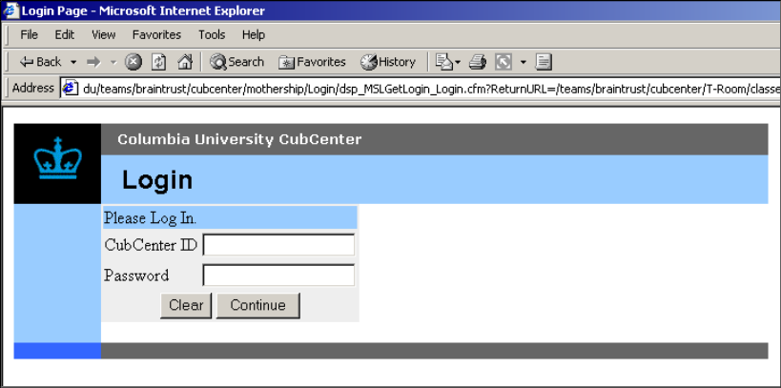

User Manual: Viewing Audit Log Events

Using the Audit Log Event Search Module
Access | Through the Main Menu of the Context Menu.
Description | The module is a search engine for events that have been logged into the CubCenter. The module enables to generate a list of these events by criterions.
Usage | The interface is divided into two panes: Event/s and Date and Time of Event/s (see picture).  The Event/s pane:  Under this pane enter the attributes of the desired event/s for the search. Each of the attributes of an event (Priority, Module, Activity, Person Id) may be specified in order to narrow the group of events to be searched. For example, if one enters a “Person Id” number, only events with this person id will be returned. (Leaving this field blank, or the activity field blank, will cause the search to ignore these fields. I.e. return all types of these fields).
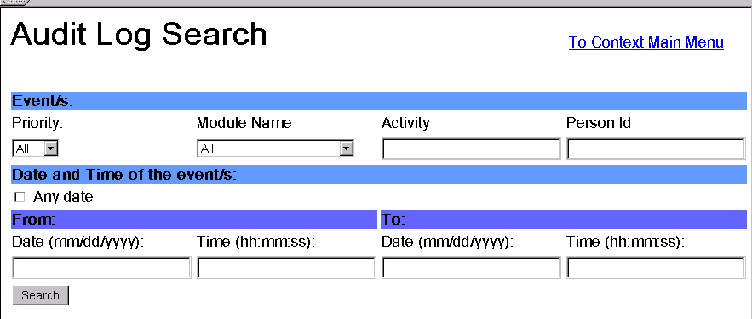
The Date and Time of the Event/s pane:
Under this pane enter the date/time range of the event/s to search. To search for an event/s that occurred on “any date” check the “All date.” To specify a date range enter the “From” date and the “To” date. (Note: the date/time is inclusive for the “From” date and exclusive for the “To” date).
Tip: if no time variable is entered the “Time” fields will default to 00:00:00.
Tip: You can exclude the seconds by entering time like this: hh:mm

To search the event/s press the “search” button. The result of the search will be displayed under the Date and Time of the Event/s pane. (Note: if your search returned a large number of events, the rendering of the table of the events might take some time. Be patients).

User Manual: Maintaining Context Data

Using the Context Data Maintenance GUI
Access | Through the Context Data Component Menu
Description | This user interface has a feature to  Create Entity  Add Person, User , Class and etc.  Edit Entity  Edit Entity’s Attributes such as, email, address, course name and etc.  Remove Entity  Delete Entity from the Database.  Create Relationship  Assign relationship between two Enity.  For example,  Relationship Student: Person -> Class  Relationship TA: Person -> Class  Relationship Instructor Person -> Class  Remove Relationship  Remove Relationship which you have assign with above menu.

If you would like to add, edit or remove entities or relationships from the system, select “Context Data Maintenance ”

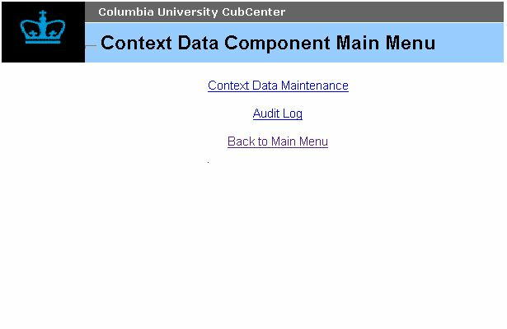

This is the “Context Data Maintenance Menu”.

If you’d like to create a new entity, click on “Create Entity”
and follow the steps in < Create Entity >.
If you’d like to create a new entity, click on “Edit Entity”
and follow the steps in < Edit Entity >.
If you’d like to create a new entity, click on “Remove Entity”
and follow the steps in < Remove Entity >.
If you’d like to create a new entity, click on “Create Relationship”
and follow the steps in < Create Relationship >.
If you’d like to create a new entity, click on “Remove Relationship”
and follow the steps in < Remove Relationship >.

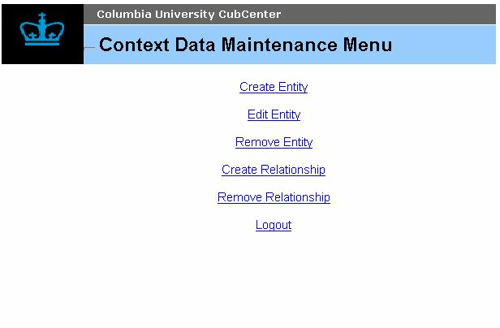

Create Entity
Select Entity type, which you want to create from the list. And press “Next”
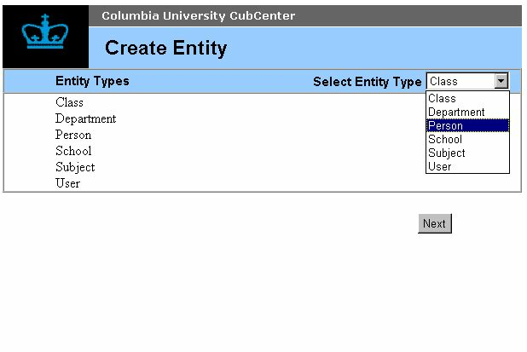

Enter necessary information to the for. You could leave couple of the field
blank. After you have finished entering data press “Save”
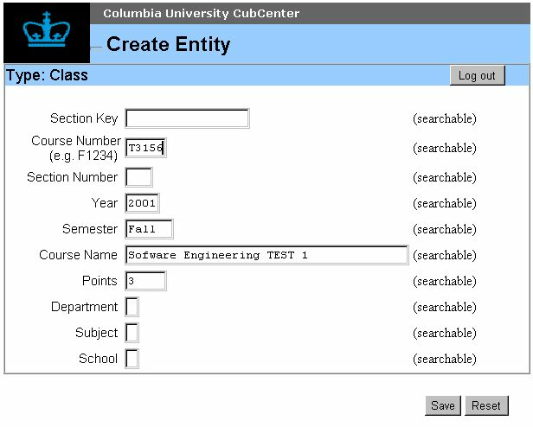

The system will show you what have been saved. Press “Return to Menu” and go back to “Context Data Maintenance Menu”

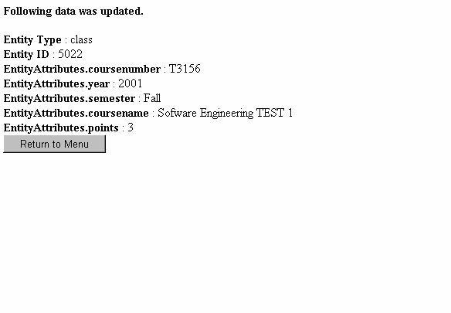

Edit Entity
Select Entity type which you want to edit from the list. And press “Next”

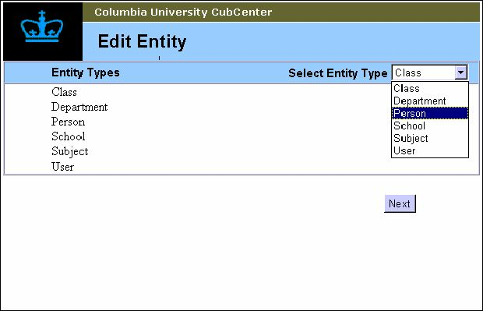

From the selection what you have made above, system will search entire database and show you how much did it match . Enter search criteria in any field to make a search and press “next”.
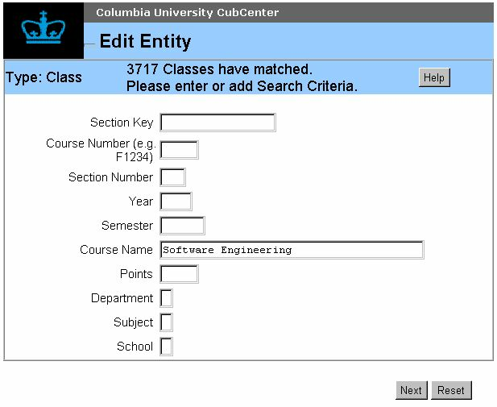

Select one entity from the list what have matched.
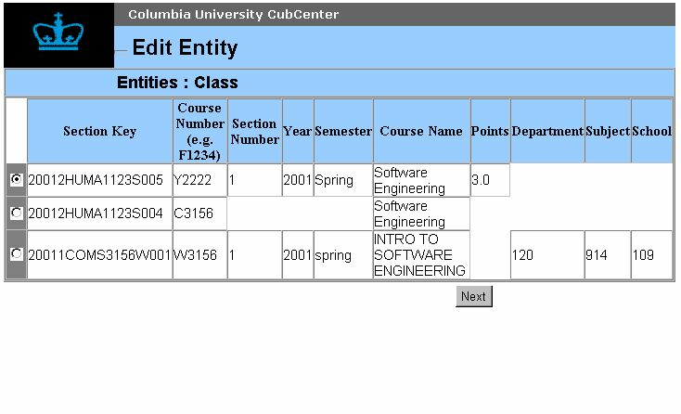

Select one entity from the list what have matched.
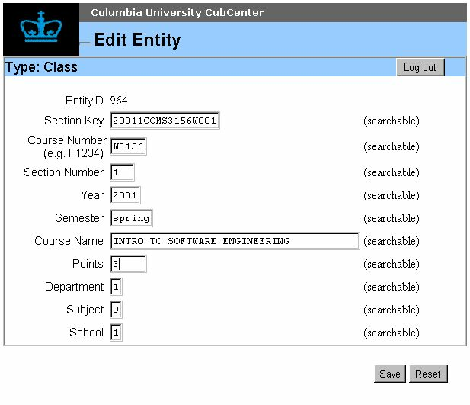

This screen you what have you made changes in previous page.

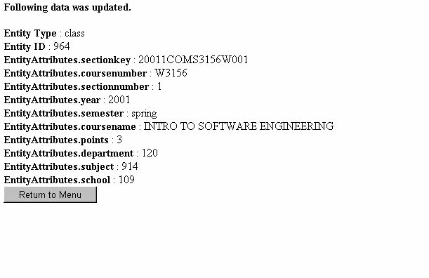
Remove Entity
Select Entity type from the list of the Entity which you would like to erase from the database.

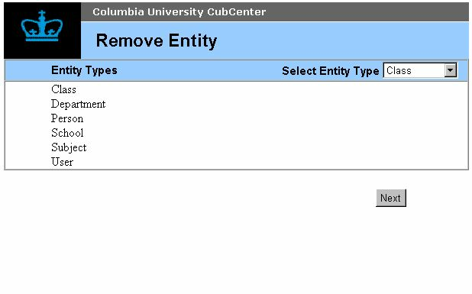

Type in search criteria to make a query from the database.
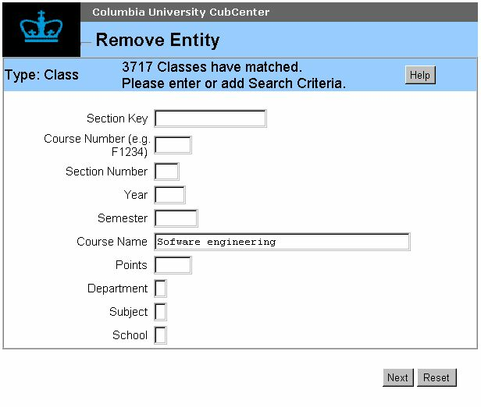

Pick one entity to delete from the list and press “Next”. Then it will erase it from the database.

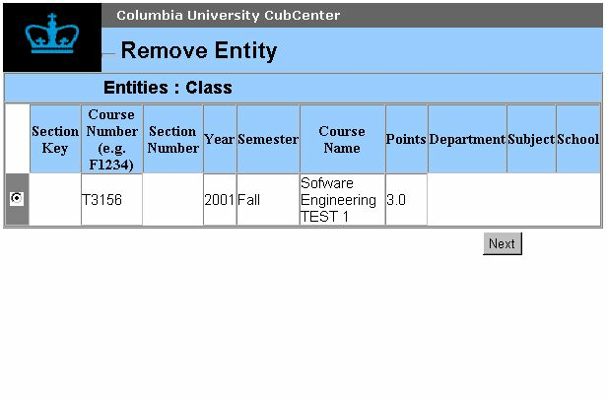
Announce you what you have deleted.

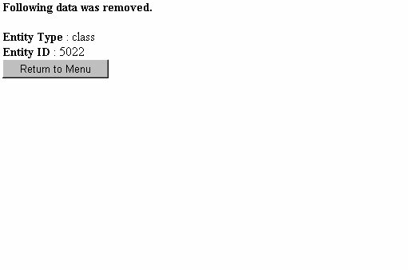

Create Relationship
I would like to explain our data representation in our database first here.
The Entity what have created in the “Create Entity” menu does not automatically assign any relationship.
But the data without any relationship is mostly useless and this screen will allow you to assign relationship between two entities. For instance, assign “person” to “class” with “student” relationship or assign “person” to “class” with “TA” relationship

For the first step, start selecting source entity.
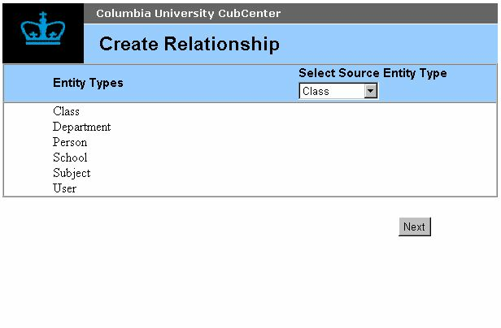

Pick one entity.

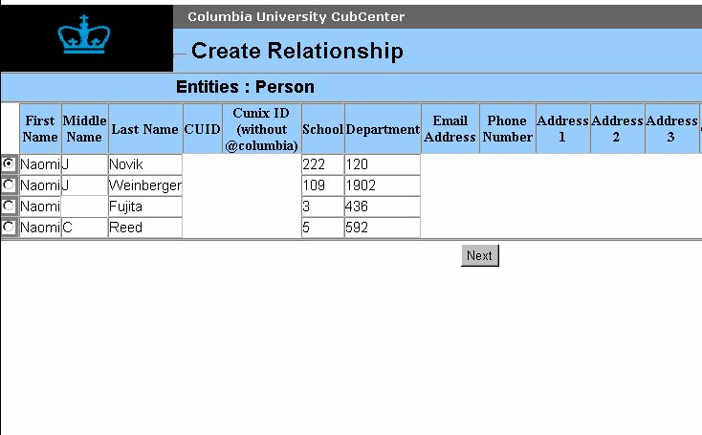

Select one relationship type to create Instructor, Student and TA.

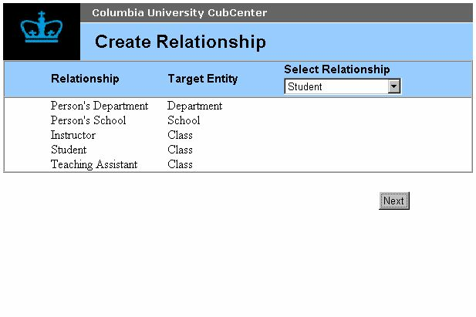

Make a search criteria in this screen.
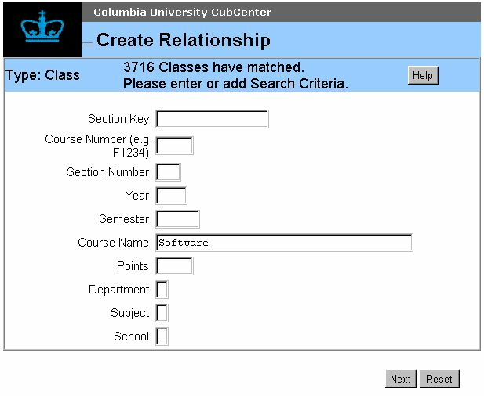

Pick one entity for target entity.
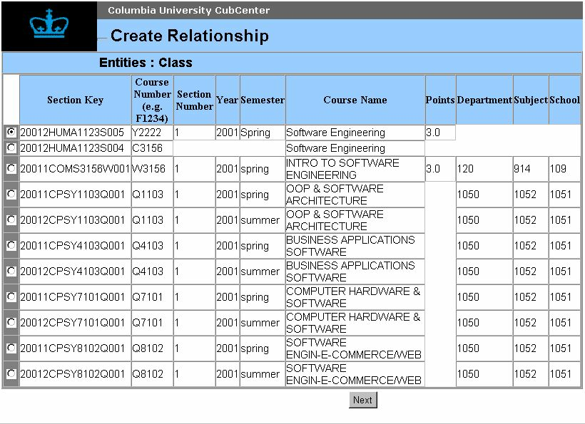
Show the relationship what have created.
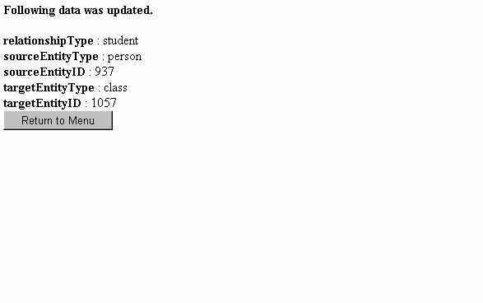

Remove Relationship
Chose source entity relationship from selecting entity type.

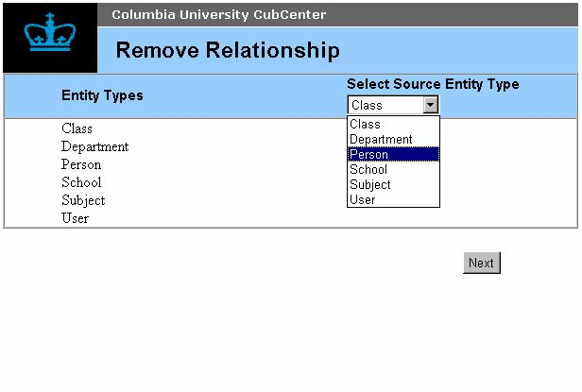
Pick one Entity for the source entity.

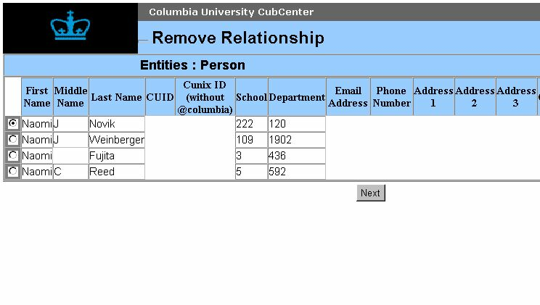
Select relationship type to remove.
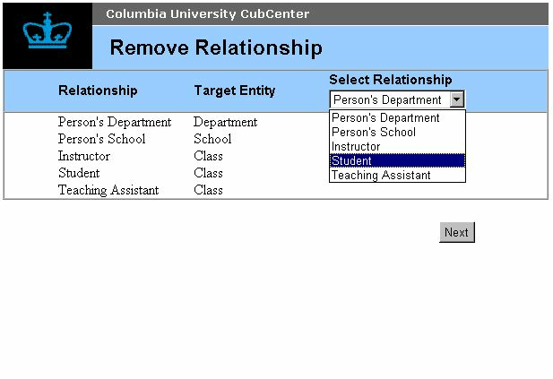
Chose Target Entity for the relationship.
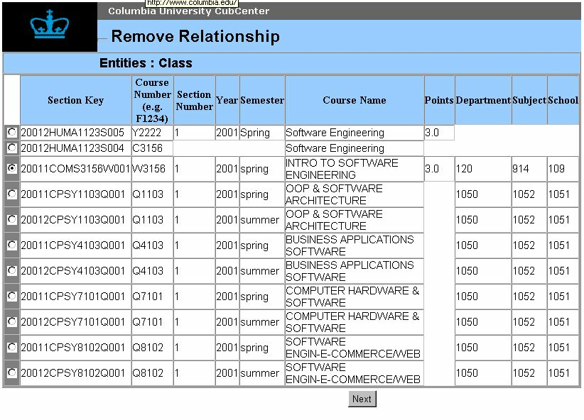
This is the relationship what you have deleted.
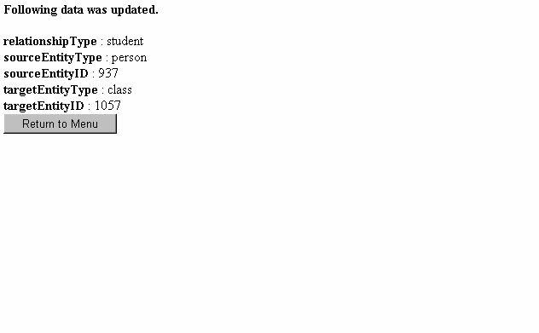

References and Glossary

Cold Fusion 4.5:
http://www.allaire.com/

Appendices

Sample Usage
The following pages contain examples on how to use each of the API functions.

Login Interface (MSL_*)

MSL_GetLogin
Get the currently logged on user:
<CFModule template=“(mothership path)/Login/index.cfm”
fuseaction=”MSL_GetLogin”
returnURL=”http://path/to/my/module”
moduleName=”context”>

Welcome, #MSL_PersonID#

MSL_Logout
Log out the current user.

<CFModule template=“(mothership path)/Login/index.cfm”
fuseaction=”MSL_Logout”>

MSL_GetUserLoginStatus
Check the status of user 123
<CFModule template=“(mothership path)/Login/index.cfm”
fuseaction=”MSL_GetUserLoginStatus”
personID=123>

<CFIf MSL_LoggedIn>
User was last using module #MSL_Module#
<CFElse>
User is not logged in
</CFIf>
Prototype | MSL_GetUserLoginStatus(<PersonID>)
Description | This function is used to determine whether a user is currently using the system, and, if so, what module the person has used most recently.
Input Parameters | - <PersonID> is an integer; a number that uniquely identifies the user to the system
Output Variables | - MSL_LoggedIn is an integer; 0 indicates the user is not logged in, any other number indicates that the user is logged in  - MSL_Module is a string; the name of the module that the person accessed last

MSL_GetPeekLogin
Get the currently logged on user:
<CFModule template=“(mothership path)/Login/index.cfm”
fuseaction=”MSL_GetPeekLogin”>

<CFIf MSL_LoginAvailable>
Welcome, #MSL_PersonID#
<CFElse>
There is nobody currently logged in.
</CFIf>

Context Data Query Interface (MSCQ_*)

MSCQ_GetClassListByPerson
List the role, ID and name of all classes for the person whose CUID is “111-22-3333”

<CFModule template=“(mothership path)/ContextDatabase/index.cfm”
fuseaction="MSCQ_GetClassListByPerson"
cuid="111-22-3333">

<CFIf MSCQ_Status IS NOT 0>
Error loading classes: <FONT color="red">#MSCQ_Error#</font>
<CFElse>
<CFIf ArrayLen(MSCQ_ClassRoleList) IS NOT 0>
<table border=1>
<tr>
<th>Role</th>
<th>Class ID</th>
<th>Course name</th>
</tr>

<CFLoop index=iRow FROM=1 TO=#ArrayLen(MSCQ_ClassRoleList)#>
<tr>
<td>#MSCQ_ClassRoleList[iRow].role#</td>
<td>#MSCQ_ClassRoleList[iRow].classid#</td>
<td>#MSCQ_ClassRoleList[iRow].coursename#</td>
</tr>
</CFLoop>
</Table>
<CFElse>
No classes found
</CFIf>
</CFIf>

MSCQ_GetPersonListByClass
List the role, and name of all people for the class whose section key is “20011NBHV4100G001”

<CFModule template=“(mothership path)/ContextDatabase/index.cfm”
fuseaction="MSCQ_GetPersonListByClass"
sectionkey="20011NBHV4100G001">

<CFIf MSCQ_Status IS NOT 0>
Error loading people: <FONT color="red">#MSCQ_Error#</font>
<CFElse>
<CFIf ArrayLen(MSCQ_PersonRoleList) IS NOT 0>
<table border=1>
<tr>
<th>Role</th>
<th>ID</th>
<th>First Name</th>
<th>Last Name</th>
</tr>

<CFLoop index=iRow FROM=1 TO=#ArrayLen(MSCQ_PersonRoleList)#>
<tr>
<td>#MSCQ_PersonRoleList[iRow].role#</td>
<td>#MSCQ_PersonRoleList[iRow].personid#</td>
<td>#MSCQ_PersonRoleList[iRow].firstname#</td>
<td>#MSCQ_PersonRoleList[iRow].lastname#</td>
</tr>
</CFLoop>
</Table>
<CFElse>
No people found
</CFIf>
</CFIf>

MSCQ_GetPersonDetails
Get the first and last name of the person whose ID is 1234

<CFModule template=“(mothership path)/ContextDatabase/index.cfm”
fuseaction="MSCQ_GetPersonDetails"
personid=1234>

<CFIf MSCQ_Status IS NOT 0>
Error loading person details: <FONT color="red">#MSCQ_Error#</font>
<CFElse>
#MSCQ_Person[iRow].firstname#
#MSCQ_Person[iRow].lastname#
</CFIf>

MSCQ_GetClassDetails
Get the course name of the class whose section key is “20011NBHV4100G001”

<CFModule template=“(mothership path)/ContextDatabase/index.cfm”
fuseaction="MSCQ_GetClassDetails"
sectionkey=”20011NBHV4100G001”>

<CFIf MSCQ_Status IS NOT 0>
Error loading class details: <FONT color="red">#MSCQ_Error#</font>
<CFElse>
#MSCQ_Class[iRow].coursename#
</CFIf>

MSCQ_GetClassList
Get the course number of all fall 2001 classes whose department is AFAS.

<CFModule template=“(mothership path)/ContextDatabase/index.cfm”
fuseaction="MSCQ_GetClassList"
year=2001 semester="fall" department="AFAS">

<CFIf MSCQ_Status IS NOT 0>
Error loading classes: <FONT color="red">#MSCQ_Error#</font>
<CFElse>
<CFIf ArrayLen(MSCQ_ClassList) IS NOT 0>
<table border=1>
<tr>
<th>Class ID</th>
<th>Course name</th>
</tr>

<CFLoop index=iRow FROM=1 TO=#ArrayLen(MSCQ_ClassList)#>
<tr>
<td>#MSCQ_ClassList[iRow].classid#</td>
<td>#MSCQ_ClassList[iRow].coursename#</td>
</tr>
</CFLoop>
</Table>
<CFElse>
No classes found
</CFIf>
</CFIf>

MSCQ_GetEntityTypeList
List all entity types.

<CFMODULE Template=“(mothership path)/ContextDatabase/index.cfm”
fuseaction="MSCQ_getEntityTypeList">

Status: #MSCQ_Status#<br>

<CFIf #MSCQ_Status# IS NOT 0>
Error: <font color="red">#MSCQ_Error#</font><br>
<CFElse>
<table border=1>
<tr>
<th colspan=3>Entity Types</th>
</tr>
<tr>
<th>Entity Type</th>
<th>Display Name</th>
<th>Can Login</th>
</tr>

<CFLoop index="iTypeNum" from="1" to="#ArrayLen(MSCQ_EntityTypes)#">
<tr>
<td>#MSCQ_EntityTypes[iTypeNum].entityType#</td>
<td>#MSCQ_EntityTypes[iTypeNum].displayName#</td>
<td>#MSCQ_EntityTypes[iTypeNum].canLogin#</td>
</tr>
</CFLoop>
</table>
</CFIF>

MSCQ_GetEntityTypeDetails
List the details for the entity type “Person”

<CFMODULE Template=“(mothership path)/ContextDatabase/index.cfm”
fuseaction="MSCQ_getEntityTypeDetails"
entityType="Person">

Status: #MSCQ_Status#<br>

<CFIf #MSCQ_Status# IS NOT 0>
Error: <font color="red">#MSCQ_Error#</font><br>
<CFElse>
Entity Type: #MSCQ_EntityType#<br>
Display Name: #MSCQ_DisplayName#<br>
Can Login: #MSCQ_CanLogin#<br>

<table border=1>
<tr>
<th colspan=5>Attributes</th>
</tr>
<tr>
<th>Name</th>
<th>Display Name</th>
<th>Type</th>
<th>Constraints</th>
<th>Searchable</th>
</tr>

<CFLoop index="iAttNum" from="1" to="#ArrayLen(MSCQ_Attributes)#">
<tr>
<td>#MSCQ_Attributes[iAttNum].attributeName#</td>
<td>#MSCQ_Attributes[iAttNum].displayName#</td>
<td>#MSCQ_Attributes[iAttNum].dataType#</td>
<td>#MSCQ_Attributes[iAttNum].dataConstraints#</td>
<td>#MSCQ_Attributes[iAttNum].searchable#</td>
</tr>
</CFLoop>
</table>
</CFIF>

MSCQ_GetRelationshipTypeList
List all relationship types.

<CFMODULE Template=“(mothership path)/ContextDatabase/index.cfm”
fuseaction="MSCQ_getRelationshipTypeList">

Status: #MSCQ_Status#<br>

<CFIf #MSCQ_Status# IS NOT 0>
Error: <font color="red">#MSCQ_Error#</font><br>
<CFElse>
<table border=1>
<tr>
<th colspan=2>Relationship Types</th>
</tr>
<tr>
<th>Relationship Type</th>
<th>Display Name</th>
</tr>

<CFLoop index="iTypeNum" from="1" to="#ArrayLen(MSCQ_RelationshipTypes)#">
<tr>
<td>#MSCQ_RelationshipTypes[iTypeNum].relationshipType#</td>
<td>#MSCQ_RelationshipTypes[iTypeNum].displayName#</td>
</tr>
</CFLoop>
</table>
</CFIF>

MSCQ_GetValidRelationshipList
List all valid relationships.

<CFMODULE Template=“(mothership path)/ContextDatabase/index.cfm”
fuseaction="MSCQ_getValidRelationshipList">

Status: #MSCQ_Status#<br>

<CFIf #MSCQ_Status# IS NOT 0>
Error: <font color="red">#MSCQ_Error#</font><br>
<CFElse>
<table border=1>
<tr>
<th colspan=6>Valid Relationships</th>
</tr>
<tr>
<th colspan=2>Relationship</th>
<th colspan=2>Source Entity</th>
<th colspan=2>Target Entity</th>
</tr>
<tr>
<th>Type</th>
<th>Display Name</th>
<th>Type</th>
<th>Display Name</th>
<th>Type</th>
<th>Display Name</th>
</tr>

<CFLoop index="iTypeNum" from="1" to="#ArrayLen(MSCQ_ValidRelationships)#">
<tr>
<td>#MSCQ_ValidRelationships[iTypeNum].relationshipType#</td>
<td>#MSCQ_ValidRelationships[iTypeNum].relationshipDisplayName#</td>
<td>#MSCQ_ValidRelationships[iTypeNum].sourceEntityType#</td>
<td>#MSCQ_ValidRelationships[iTypeNum].sourceDisplayName#</td>
<td>#MSCQ_ValidRelationships[iTypeNum].targetEntityType#</td>
<td>#MSCQ_ValidRelationships[iTypeNum].targetDisplayName#</td>
</tr>
</CFLoop>
</table>
</CFIF>

MSCQ_GetLoginInformation
Validate login for user “jsmith” password “123xyz”

<CFMODULE Template=“(mothership path)/ContextDatabase/index.cfm”
fuseaction="MSCQ_getLoginInformation"
username="jsmith"
password="123xyz">

Status: #MSCQ_Status#<br>

<CFIf #MSCQ_Status# IS NOT 0>
Error: <font color="red">#MSCQ_Error#</font><br>
<CFElse>
Login exists: #MSCQ_LoginExists#<br>

<CFIf MSCQ_LoginExists>
Entity Type: #MSCQ_EntityType#<br>
Entity ID: #MSCQ_EntityID#<br>
</CFIf>
</CFIF>

MSCQ_ContextDataSearch
List the first name, last name, and user name of all people who are in a class whose TA has a user name of “fred”.

<CFScript>
asDesiredAttributes=ListToArray("firstname,lastname,username");

astSearchCriteria=ArrayNew(1);

// Search for a person
astSearchCriteria[1]=StructNew();
astSearchCriteria[1].field="_entitytype";
astSearchCriteria[1].value="person";

// A person who is a student (i.e. has a student relationship)
astSearchCriteria[3]=StructNew();
astSearchCriteria[3].field="_relationship";
astSearchCriteria[3].value=ArrayNew(1);
astSearchCriteria[3].value[1]=StructNew();
astSearchCriteria[3].value[1].field="type";
astSearchCriteria[3].value[1].value="student";

// ...a student of a class of a class...
astSearchCriteria[3].value[2]=StructNew();
astSearchCriteria[3].value[2].field="target";
astSearchCriteria[3].value[2].value=ArrayNew(1);
astSearchCriteria[3].value[2].value[1]=StructNew();
astSearchCriteria[3].value[2].value[1].field="_entityType";
astSearchCriteria[3].value[2].value[1].value="class";

// ...a class that is related to a TA...
astSearchCriteria[3].value[2].value[2]=StructNew();
astSearchCriteria[3].value[2].value[2].field="_relationship";
astSearchCriteria[3].value[2].value[2].value=ArrayNew(1);
astSearchCriteria[3].value[2].value[2].value[1]=StructNew();
astSearchCriteria[3].value[2].value[2].value[1].field="type";
astSearchCriteria[3].value[2].value[2].value[1].value="teachingassistant";

// ...a TA who is a person...
astSearchCriteria[3].value[2].value[2].value[2]=StructNew();
astSearchCriteria[3].value[2].value[2].value[2].field="source";
astSearchCriteria[3].value[2].value[2].value[2].value=ArrayNew(1);
astSearchCriteria[3].value[2].value[2].value[2].value[1]=StructNew();
astSearchCriteria[3].value[2].value[2].value[2].value[1].field="_entityType";
astSearchCriteria[3].value[2].value[2].value[2].value[1].value="person";

// ...whose username is "fred"...
astSearchCriteria[3].value[2].value[2].value[2].value[2]=StructNew();
astSearchCriteria[3].value[2].value[2].value[2].value[2].field="username";
astSearchCriteria[3].value[2].value[2].value[2].value[2].value="fred";
</CFScript>

<CFModule template="(mothership path)/ContextDatabase/index.cfm"
fuseaction="MSCQ_contextDataSearch"
searchtype="entity"
searchcriteria=#astSearchCriteria#
entityattributes=#asDesiredAttributes#
>

Status: #MSCQ_Status#<br>

<CFIf #MSCQ_Status# IS NOT 0>
Error: <font color="red">#MSCQ_Error#</font><br>
<CFElse>
<table border=1>
<tr>
<th>First Name</th>
<th>Last Name</th>
<th>Username</th>
</tr>

<CFLoop index="iPerson" from="1" to="#ArrayLen(MSCQ_Entities)#">
<tr>
<td>#MSCQ_Entities[iPerson].firstname#</td>
<td>#MSCQ_Entities[iPerson].lasstname#</td>
<td>#MSCQ_Entities[iPerson].username#</td>
</tr>
</CFLoop>
</table>
</CFIF>

Audit Log Insertion Interface (MSALI_*)

MSALI_LogEvent
Log a simple notice.

<CFModule template="(mothership path)/AuditLog/index.cfm"
fuseaction="MSALI_LogEvent"
priority=100
moduleName="CONTEXT"
activity="Saving Entity"
activityInfo="Entity type person, ID 112 saved."
personID=16>

Audit Log Insertion Interface (MSALQ_*)

MSALQ_QueryAuditLoggedEvents
Invoke the audit log query screen.

<CFModule template="(mothership path)/AuditLogQuery/index.cfm"
fuseaction="MSALQ_QueryAuditLoggedEvents">

Context Data Maintenance Interface (MSCM_*)
MSCM_SaveEntity
Save a new entity type of department, with acronym=”COMS” and name=”Computer Science”

<CFSet stInfo=#StructNew#>
<CFSet stInfo.acronym=”COMS”>
<CFSet stInfo.name=”Computer Science”>

<CFMODULE Template="(mothership path)/ContextDatabase/index.cfm"
fuseaction="MSCM_saveEntity"
entityType=”department”
entityAttributes=#stInfo#
strictAttributes=true
userID=123>

Status: #MSCM_Status#<br>

<CFIf #MSCM_Status# IS NOT 0>
Error: <font color="red">#MSCM_Error#</font><br>
<CFElse>
New Entity ID: #MSCM_EntityID#<br>
</CFIF>

MSCM_RemoveEntity
Remove class with entity ID 345

<CFMODULE Template="(mothership path)/ContextDatabase/index.cfm"
fuseaction="MSCM_removeEntity"
entityType=”class”
entityID=345
userID=123>

Status: #MSCM_Status#<br>

<CFIf #MSCM_Status# IS NOT 0>
Error: <font color="red">#MSCM_Error#</font><br>
</CFIf>

MSCM_SaveRelationship
Create “student” relationship between person ID 789 and class ID 456.

<CFMODULE Template="(mothership path)/ContextDatabase/index.cfm"
fuseaction="MSCM_SaveRelationship"
relationshipType=”student”
sourceEntityType=”person”
sourceEntityID=789
targetEntityType=”class”
targetEntityID=456
userID=123>

Status: #MSCM_Status#<br>

<CFIf #MSCM_Status# IS NOT 0>
Error: <font color="red">#MSCM_Error#</font><br>
</CFIf>

MSCM_RemoveRelationship
Remove “student” relationship between person ID 789 and class ID 456.

<CFMODULE Template="(mothership path)/ContextDatabase/index.cfm"
fuseaction="MSCM_RemoveRelationship"
relationshipType=”student”
sourceEntityType=”person”
sourceEntityID=789
targetEntityType=”class”
targetEntityID=456
userID=123>

Status: #MSCM_Status#<br>

<CFIf #MSCM_Status# IS NOT 0>
Error: <font color="red">#MSCM_Error#</font><br>
</CFIf>

Schema Definition Interface (MSSD_*)
MSSD_CreateRelationshipType
Create relationship type “student”

<CFMODULE Template="(mothership path)/ContextDatabase/index.cfm"
fuseaction="MSSD_createRelationshipType"
relationshipType="student"
displayName="Student"
userID=123>

<CFOutput>
Status: #MSSD_Status#<br>
<CFIf #MSSD_Status# IS NOT 0>
Error: <font color="red">#MSSD_Error#</font></br>
</CFIF>
</CFOutput>

MSSD_CreateValidRelationship
Allow relationship type “student” between a person and a class entity type.

<CFMODULE Template="(mothership path)/ContextDatabase/index.cfm"
fuseaction="MSSD_createValidRelationship"
relationshipType="student"
sourceEntityType="person"
targetEntityType="class"
userID=123>

<CFOutput>
Status: #MSSD_Status#<br>

<CFIf #MSSD_Status# IS NOT 0>
Error: <font color="red">#MSSD_Error#</font></br>
</CFIF>
</CFOutput>

MSSD_CreateEntityType
Create “Class” Entity type.

<CFSet astClassAttributes=ArrayNew(1)>

<CFSet stAttribute=StructNew()>
<CFSet stAttribute.attributeName="sectionkey">
<CFSet stAttribute.displayName="Section Key">
<CFSet stAttribute.dataType="regexp">
<CFset stAttribute.dataConstraints="17,(20|19)[0-9][0-9][0-9][A-Z][A-Z][A-Z][A-Z][0-9][0-9][0-9][0-9][A-Z][0-9][0-9][0-9]">
<CFSet stAttribute.searchable=true>
<CFSet astClassAttributes[ArrayLen(astClassAttributes)+1]=stAttribute>

<CFSet stAttribute=StructNew()>
<CFSet stAttribute.attributeName="coursenumber">
<CFSet stAttribute.displayName="Course Number (e.g. F1234)">
<CFSet stAttribute.dataType="regexp">
<CFset stAttribute.dataConstraints="5,[A-Z][0-9][0-9][0-9][0-9]">
<CFSet stAttribute.searchable=true>
<CFSet astClassAttributes[ArrayLen(astClassAttributes)+1]=stAttribute>

<CFSet stAttribute=StructNew()>
<CFSet stAttribute.attributeName="sectionnumber">
<CFSet stAttribute.displayName="Section Number">
<CFSet stAttribute.dataType="regexp">
<CFset stAttribute.dataConstraints="3,[0-9]*[1-9]">
<CFSet stAttribute.searchable=true>
<CFSet astClassAttributes[ArrayLen(astClassAttributes)+1]=stAttribute>

<CFSet stAttribute=StructNew()>
<CFSet stAttribute.attributeName="year">
<CFSet stAttribute.displayName="Year">
<CFSet stAttribute.dataType="regexp">
<CFset stAttribute.dataConstraints="4,(19|20)[0-9][0-9]">
<CFSet stAttribute.searchable=true>
<CFSet astClassAttributes[ArrayLen(astClassAttributes)+1]=stAttribute>

<CFSet stAttribute=StructNew()>
<CFSet stAttribute.attributeName="semester">
<CFSet stAttribute.displayName="Semester">
<CFSet stAttribute.dataType="regexp">
<Cfset stAttribute.dataConstraints="6,([S,s][P,p][R,r][I,i][N,n][G,g])|([S,s][U,u][M,m][M,m][E,e][R,r])|([F,f][A,a][L,l][L,l])">
<CFSet stAttribute.searchable=true>
<CFSet astClassAttributes[ArrayLen(astClassAttributes)+1]=stAttribute>

<CFSet stAttribute=StructNew()>
<CFSet stAttribute.attributeName="coursename">
<CFSet stAttribute.displayName="Course Name">
<CFSet stAttribute.dataType="string">
<CFset stAttribute.dataConstraints="40">
<CFSet stAttribute.searchable=true>
<CFSet astClassAttributes[ArrayLen(astClassAttributes)+1]=stAttribute>

<CFSet stAttribute=StructNew()>
<CFSet stAttribute.attributeName="points">
<CFSet stAttribute.displayName="Points">
<CFSet stAttribute.dataType="number">
<CFset stAttribute.dataConstraints="5,1">
<CFSet stAttribute.searchable=true>
<CFSet astClassAttributes[ArrayLen(astClassAttributes)+1]=stAttribute>

<CFSet stAttribute=StructNew()>
<CFSet stAttribute.attributeName="department">
<CFSet stAttribute.displayName="Department">
<CFSet stAttribute.dataType="entity">
<CFset stAttribute.dataConstraints="department">
<CFSet stAttribute.searchable=true>
<CFSet astClassAttributes[ArrayLen(astClassAttributes)+1]=stAttribute>

<CFSet stAttribute=StructNew()>
<CFSet stAttribute.attributeName="subject">
<CFSet stAttribute.displayName="Subject">
<CFSet stAttribute.dataType="entity">
<CFset stAttribute.dataConstraints="subject">
<CFSet stAttribute.searchable=true>
<CFSet astClassAttributes[ArrayLen(astClassAttributes)+1]=stAttribute>

<CFSet stAttribute=StructNew()>
<CFSet stAttribute.attributeName="school">
<CFSet stAttribute.displayName="School">
<CFSet stAttribute.dataType="entity">
<CFset stAttribute.dataConstraints="school">
<CFSet stAttribute.searchable=true>
<CFSet astClassAttributes[ArrayLen(astClassAttributes)+1]=stAttribute>

<CFMODULE Template="(mothership path)/ContextDatabase/index.cfm"
fuseaction="MSSD_createEntityType"
entityType="class"
displayName="Class"
canLogin=false
userID=123
attributes=#astClassAttributes#>

<CFIf MSSD_Status IS NOT 0>
Class creation failed: MSSD_Error
</CFIf>

